UC3- Manage Recurring Payments
https://securedev.dpiteleconnect.com:444/wotest/main/CustRecPymtsSet.aspx

Short description.
Customer wants to setup or modify recurring payment method. Can be either CC or direct bank draft

- Remove priority
- Add view history
- Show status (Inactivate and Active)
- Instead of Delete say Deactivate
- Show active always first.
- Show start date (when you created a card) and end date (when card is deactivated)

GUI
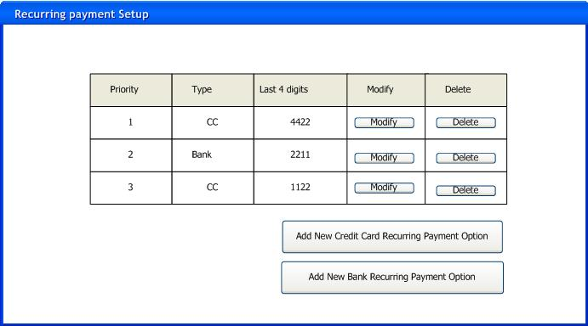

Preconditions.
Customer must be in "Active" or "Pending" (First digit of status1 is 1, 2, or 3) Status

Main Flow
- System shows a table with recurring payment options.
- Customer may select to :
  - Add new recurring payment by Executing UC3.1- Setup Recurring Payments Record if there is not Active Recurring Payment Record exists
  - Modify existing payment by Executing UC3.2- Modify Recurring Payment
  - Deactivate recurring payment
    - System will update status of the recurring Active = false

UC3.1 - Setup Recurring Payments

Preconditions.
Main flow.
- Customer selects to create new recurring payment Bank Or Credit Card payment option
- If Credit Card
  - Execute UC 3.1.1 Setup CC recurring payment
- If User selects Bank Draft
  - Execute UC 3.1.2 Setup Bank Draft recurring payment

UC 3.1.1 Setup CC recurring payment
- System asks Credit Card info
  - Credit Card Type (Visa, Master Card, Discover, AMEX) (Dropdown) Required
  - Credit Card Number Required
  - Expiration Date Required
  - Security Code (For digits at the back of the card) Required. Security code is not required for discover card
- System show prepopulated billing account info:
  - Billing First Name
  - Billing Last Name
  - Billing Address
  - Billing City
  - Billing State
  - Billing Zip
  - Phone Number
  - Email Address
- User enter CC information and may modify billing account info
- System validates if CC info is correct based on the cc type provided Algorithm for validation can be found here
- System saves recurring payment information as Active and Priority 1
- System sends email to customer.omer

Alternative Flow
4.A Invalid credit card number entered:
- System displays the message: "The credit card number is invalid. "
4.B Expiration date is setup in the past
1. System shows message "Invalid Expiration date"
5.A Active payment option already exists with the same CC number
System shows error message "This credit card already used"

UC 3.1.2 Setup Bank Draft recurring payment
- System asks Bank Draft info
  - Bank Account Number
  - Bank Route Number
  - Driver license state
  - Driver license number
- System shows billing account info pre populated
  - Billing First Name
  - Billing Last Name
  - Billing Address
  - Billing City
  - Billing State
  - Billing Zip
  - Phone Number
  - Email Address
- User enter bank account information and may modify billing account info
- System validates if routing number is a valid number. Algoritm for validation can be found here here
- System saves recurring payment information as Active and Priority 1
- System sends email to the customer: Subject "Recurring payment confirmation" Body : "Thank you for using DPI Teleconnect Online. This is the confirmation that you have setup new recurring payment using bank account."

Alternative Flow
4.A Invalid Routing number entered
1. System shows error message "Invalid Routing number entered"
5.A Payment with this bank number already exists
1. System shows message "This bank account number already used"

UC3.2 - Modify Recurring Payments

Preconditions.
Recurring payment option must in in Active status

Main flow.
- Customer selects with recurring payment to modify
- System determines if it is CC or bank payment
- If CC
  - Execute UC 3.2.1 Modify CC recurring payment
- If Bank Draft
  - Execute UC 3.2.2 Modify Bank Draft recurring payment

UC 3.2.1 Modify CC recurring payment
- System shows Credit Card info for selected payment
  - Credit Card Type (Visa, Master Card) (Dropdown) Required (ReadOlnly)
  - System shows Credit Card Number like this *********1234 ReadOnly
  - EXPIRATION DATE NOT SHOWN
  - No Security code shown
- System show billing account info:
  - Billing First Name
  - Billing Last Name
  - Billing Address
  - Billing City
  - Billing State
  - Billing Zip
  - Phone Number
  - Email Address
- User may modify billing account info
- System validates if CC info is correct based on the cc type provided Algorithm for validation can be found here
- System updates recurring payment information and set it as Active and Priority 1 Only active card can be modified
- System sends email to the customer saying Subject "Recurring payment confirmation" Body : "Thank you for using DPI Teleconnect Online. This is the confirmation that you have modified recurring payment information."

Alternative Flow
4.A Invalid credit card number entered:
- System displays the message: "The credit card number is invalid. "
4.B Expiration date is setup in the past
1. System shows message "Invalid Expiration date"
5.A Active payment option already exists with the same CC number
System shows error message "This credit card already used"

UC 3.1.2 Modify Bank Draft recurring payment
- System shows bank info for this payment
  - Bank Account Number *********1234 (user will have to enter it again to modify) (Read Only)
  - Bank Route Number **********3333 (Read ONly)
  - Don't show driver licence info

- System shows billing account info pre populated
  - Billing First Name
  - Billing Last Name
  - Billing Address
  - Billing City
  - Billing State
  - Billing Zip
  - Phone Number
  - Email Address
- User may update billing info
- System updates recurring payment information and sets it as Active and Priority 1
- System sends email to the customer: Subject "Recurring payment confirmation" Body : "Thank you for using DPI Teleconnect Online. This is the confirmation that you have modified recurring payment information."

Alternative Flow
4.A Invalid Routing number entered
1. System shows error message "Invalid Routing number entered"
5.A Payment with this bank number already exists
1. System shows message "This bank account number already used"

